

Practical File

Database Management System (DMS)
Subject Code: CSE-204P

BACHELOR OF TECHNOLOGY
Artificial Intelligence and Data Sciences



SUBMITTED BY:
Aditya Arora 2420640

Under the Guidance of Dr.
Ravneet Kaur

Department of Computer Science & Engineering Chandigarh Engineering College
Jhanjeri, Mohali - 140307

Experiment-1

Experiment Name:
Introduction to SQL and database creation

Objective:
To learn basic SQL commands

Prerequisites:
- Basic computer and OS knowledge.
- Familiarity with data concepts (tables, fields).

Key Terms: SQL, DML, DDL

System requirements:
- 4-8 GB RAM, 10-15 disk space, Windows OS
- MySQL Workbench 8.0 CE

Theory and Application:
SQL stands for Structured Query Language. It’s a language that we use to talk to database. In SQL we can store, update, retrieve and delete information from the database whenever we need it.

For example, apps like banking systems, college portals, e-commerce platforms, and social media use SQL in the background to manage huge amount of data.

SQL works with relational database systems such as:
- MySQL
- PostgreSQL
- Oracle
- SQL Server
- SQLite

A database is simply a place where data is stored in an organized way so it can be used later. Instead of keeping information on paper or in a random file, a database stores it nearly in tables.

For example, a college database may keep data about:
- Students
- Marks
- Courses
- Attendance
All these are related and can be connected to each other, which makes retrieving information fast and efficient.

MySQL
MySQL is an open-source relational database management system (RDBMS) that uses SQL to store and manage data. It has become one of the most popular database systems because it is fast, reliable, secure, and free to use. For this reason, MySQL is widely used in websites, software applications, and online services.
MySQL stores data in tables, which are organized into rows and columns. Different tables can be linked together through keys, making it easier to structure and retrieve related information.

Key Features of MySQL
  - Open-source: Anyone can download and use it without cost.
  - Relational: Data is stored in tables and can be linked through relationships.
  - SQL-based: Uses SQL commands for all major operations.
  - Scalable & Efficient: Handles large amounts of data without performance issues.
  - Cross-platform: Runs on Windows, macOS, Linux, and other systems.
  - Secure: Allows access control through authentication and privileges.
  - High Performance: Well-optimized for applications that read data frequently, such as websites.

Where MySQL is Used MySQL is commonly used in:
  - Web applications
  - E-commerce platforms
  - Content management systems (CMS)
  - Banking and finance
  - Educational institutions
  - Inventory and billing systems

Advantages of MySQL
  - Free and open-source
  - Easy to use and beginner-friendly
  - Works well with large data
  - Cross-platform and portable

MySQL – Opening a existing connection
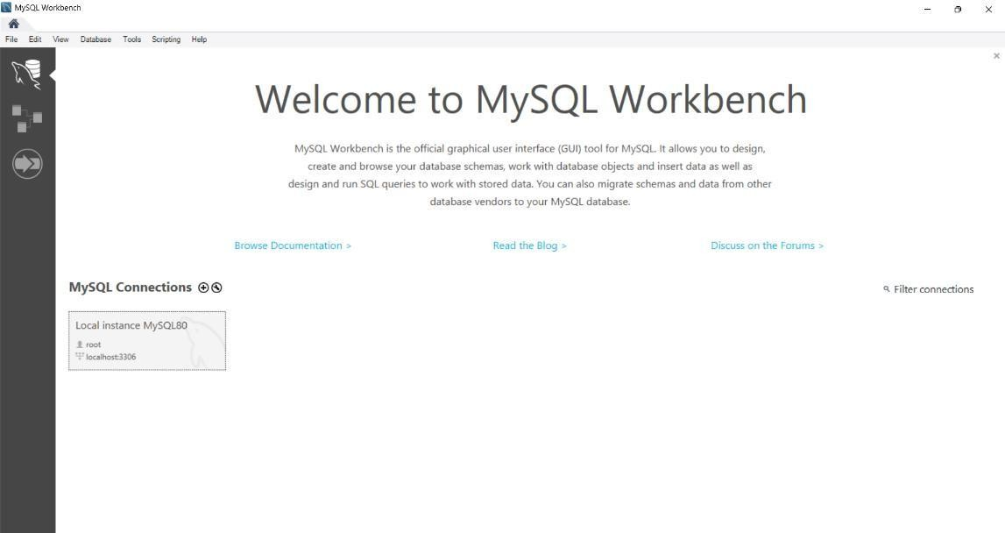
Figure 1: Opening existing connection

MySQL – Login
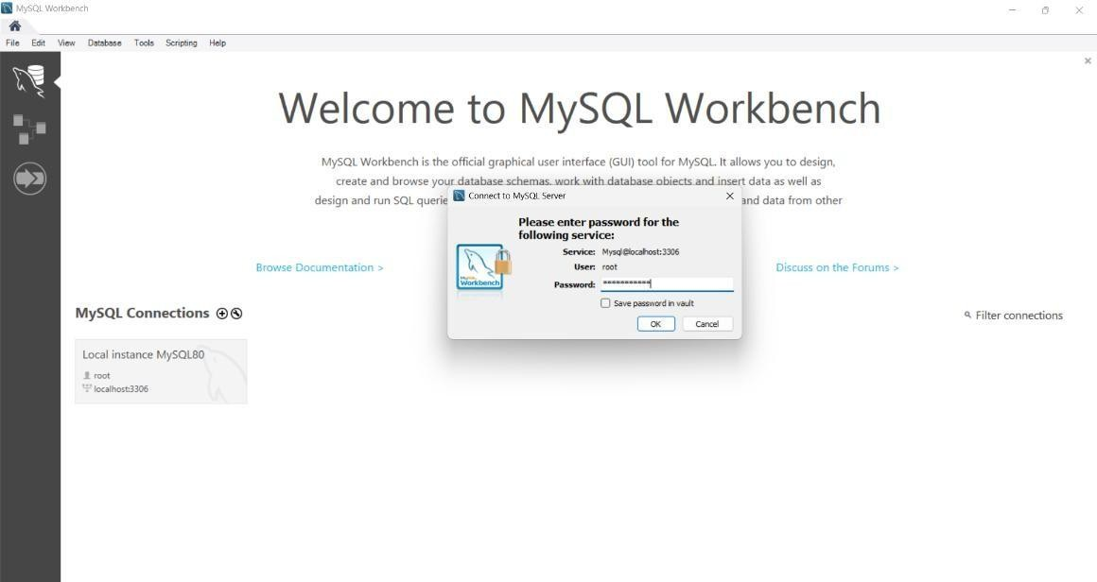
Figure 2:MySQL login

Basic SQL commands:
- CREATE
- DROP

  - CREATE & DROP Database
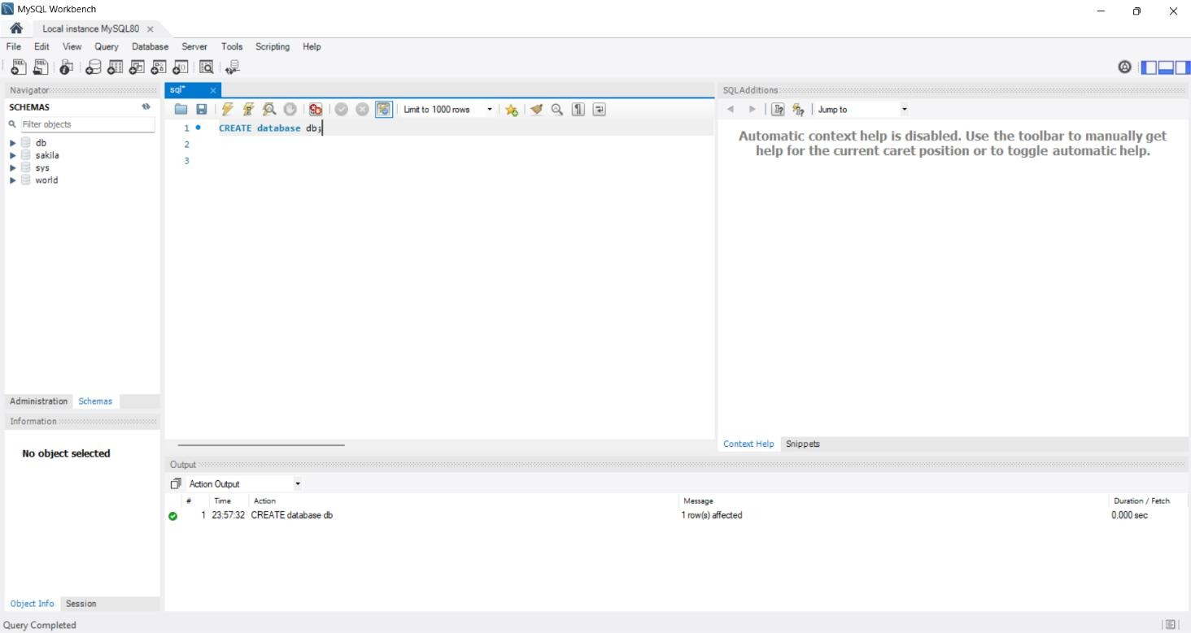
- CREATE database db; (#Run the query)
Figure 3:Creating a database

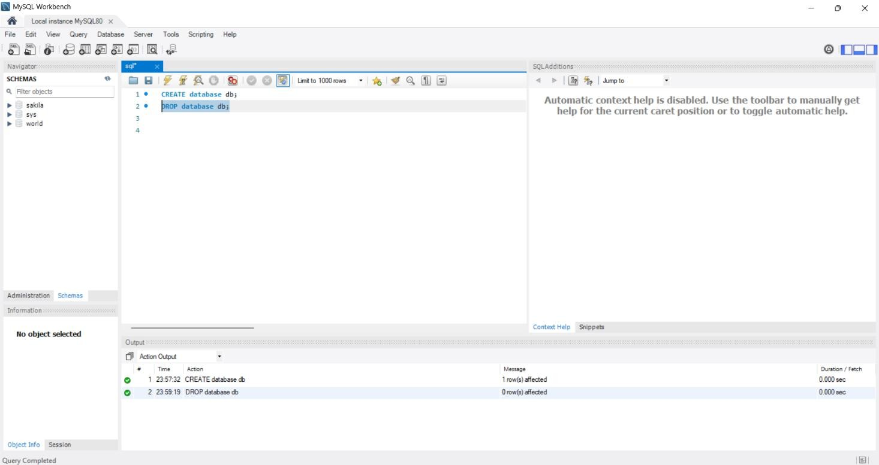
- DROP database db; (#Run the query)
Figure 4:Drop a database

Creating a table in database
CREATE database db;
USE db;
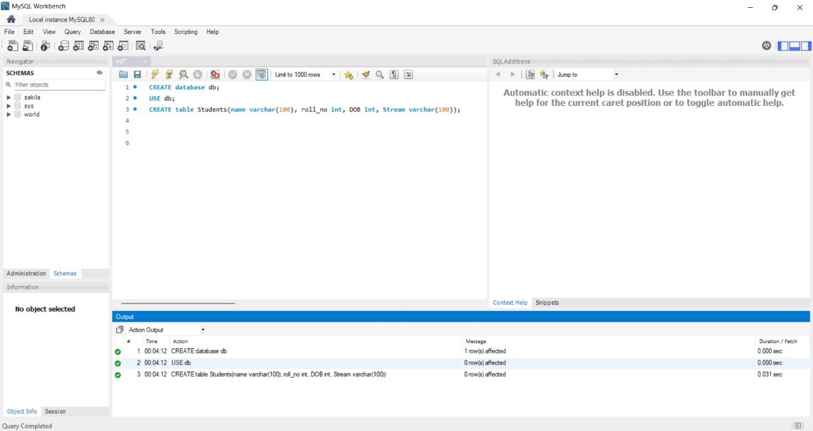
CREATE table Students(name varchar(100), roll_no int, DOB int, Stream varchar(100));
Figure 5:Creating a table

Describing a table in database
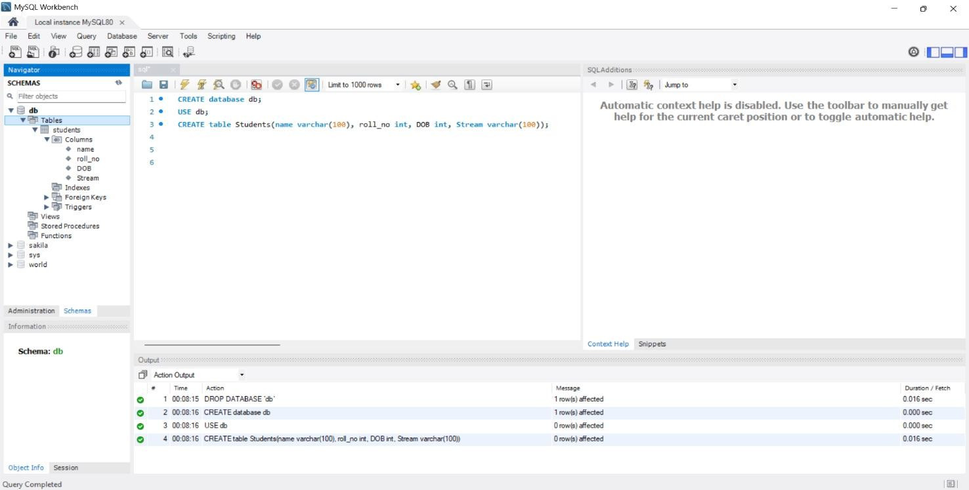
describe table db.Students;
Figure 6:Output in MySQL

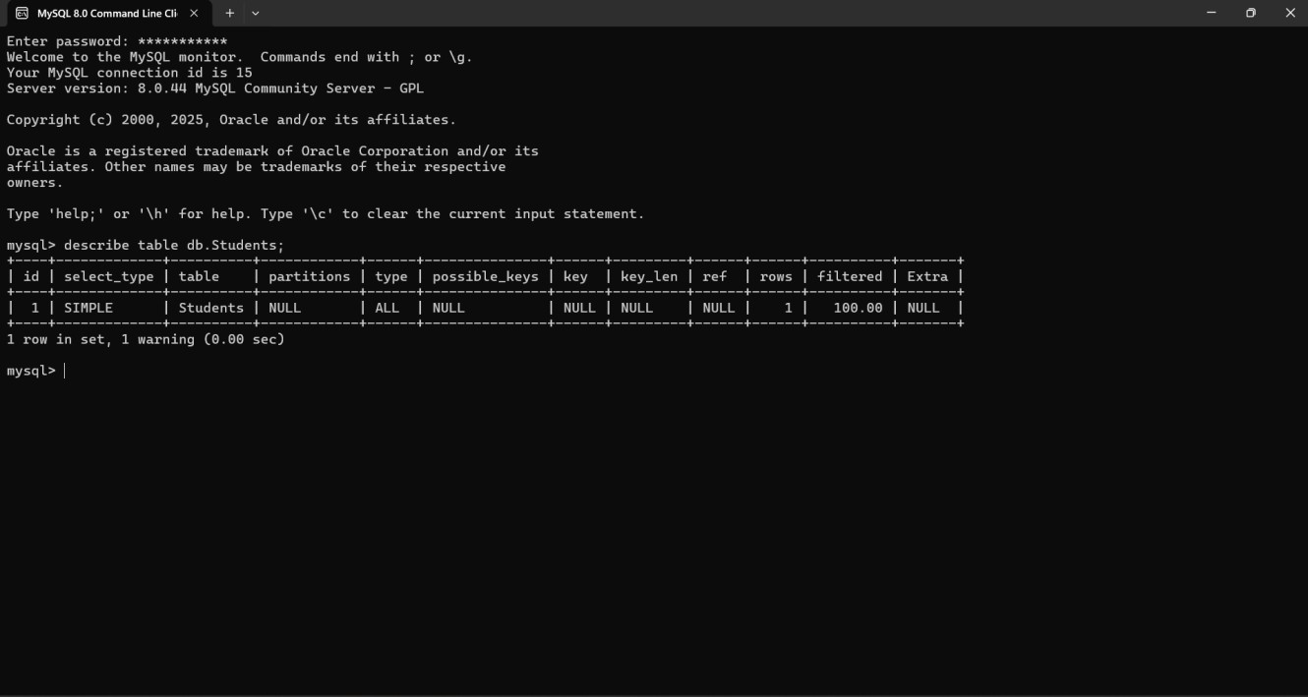
Figure 7:Output in Command Line Client

